|  |  |  |  |  |
| --- | --- | --- | --- | --- |
|  |  | | |  |
|  |  | | |  |
|  | Function Group Spec  HMI System  <<Logical>> (Allocated) | | |  |
|  |  |
|  |  |
|  |  | | |  |
| Document Type | **Function Specification** | | |  |
| Template Version | **6.0** | | |  |
| SysML Report Template Version | **O Beta (11/6/2019)** | | |  |
| Document ID | **functionspec_sysmlreporttemplate** | | |  |
| Document Location |  | | |  |
| Document Owner | **MyName** | | |  |
| Document Revision | **FGS0** | | |  |
| Document Status | **Draft** | | |  |
| Date Issued | **2021-02-16** | | |  |
| Date Revised | **2021-02-16** | | |  |
| Document Classification | GIS1 Item Number: | **27.60/35** | |  |
| GIS2 Classification: | **Confidential** | |
|  | | | | |
|  | | | | |
| Document Approval | | | | |
| Name | Role | | Email Confirmation | Date |
|  |  | |  |  |
|  |  | |  |  |

Auto-Generated by MagicDraw

Printed Copies are Uncontrolled

# Disclaimer

**This document contains Ford Motor Company Confidential information. Disclosure of the information contained in any portion of this document is not permitted without the expressed, written consent of a duly authorized representative of Ford Motor Company, Dearborn, Michigan, U.S.A.**

**Copyright, Ó 2016 Ford Motor Company**

This document contains information developed and accumulated by and for FORD MOTOR COMPANY. As such, it is a proprietary document, which, if disseminated to unauthorized persons, would provide others with restricted information, data, or procedures not otherwise available, exposing the FORD MOTOR COMPANY to potential harm.

Employees and suppliers having custody of this specification or authorized to use it must be cognizant of its proprietary nature and ensure that the information herein is not made available to unauthorized persons.

FORD MOTOR COMPANY reserves the right to protect this work as an unpublished copyrighted work in the event of an inadvertent or deliberate unauthorized publication. FORD MOTOR COMPANY also reserves its rights under copyright laws to protect this work as a published work.

This document or portions thereof shall not be distributed outside FORD MOTOR COMPANY without prior written consent. Refer all questions concerning disclosure to the author(s) or to any duly authorized representative of Ford Motor Company.

# Contents

1.1.1 Decomposition of 4

Disclaimer 16

Contents 17

2 Introduction 19

2.1 Document Purpose 19

2.2 Document Scope 19

2.3 Document Audience 19

2.3.1 Stakeholder List 19

2.4 Document Organization 19

2.4.1 Document Context 19

2.4.2 Document Structure 19

2.5 Document Conventions 20

2.5.1 Requirements Templates 20

3 Function Group Description 21

4 Functional Architecture 22

4.1 Description 22

4.2 Function List 22

4.3 Signal List 22

5 Function Specifications 23

5.1  23

5.1.1 Function Overview 23

5.1.2 Function Scope 25

5.1.3 Function Interfaces 26

5.1.4 Function Modeling 28

5.1.5 Function Requirements 28

6 Open Concerns 32

7 Revision History 33

8 Appendix 34

8.1 Data Dictionary 34

8.1.1 Logical Signals 34

8.1.2 Logical Parameters 34

8.1.3 Encoding Types 34

8.2 Glossary 34

8.2.1 Definitions 34

8.2.2 Abbreviations 35

**List of Figures**

Figure 1 Activity diagram “” depicting black box behavior collaboration 22

Figure 2: Activity Diagram of “” calling “” 26

Figure 3: 28

**List of Tables**

Table 1: - Decomposition Table 5

Table 2: Functions described in this specification 19

Table 3: List of Logical Functions 22

Table 4: Ford internal Documents 25

Table 5: Ford internal Documents *(not specified in model)* 25

Table 6: External documents and publications 25

Table 7: External documents and publications *(not specified in model)* 25

Table 8: Open Concerns *(Not supported by MagicDraw report generation.)* 32

Table 9: Definitions used in this document 35

Table 10: Abbreviations used in this document 35

# Introduction

## Document Purpose

The Function (Group) Specification (FS) specifies an individual function / a group of functions.

To get more information about the concept of feature, function and component level abstraction refer to the [Ford RE Wiki](http://wiki.ford.com/display/RequirementsEngineering/Requirements+Engineering+for+SW+Enabled+Features).

## Document Scope

The following set of functions from the [Global Feature & Function List](https://www.vsemweb.ford.com:443/tc/launchapp?-attach=true&-s=226TCSession&-o=ZmZNi0JHx3NrTDAAAAAAAAAAAAA) is described in this specification.

|  |  |  |  |
| --- | --- | --- | --- |
| **Function ID** | **Function Name** | **Owner** | **Reference** |
|  |  |  |  |

**Table 2: Functions described in this specification**

## Document Audience

The FS is authored by the owners of the individual functions. All Stakeholders, i.e., all people who have a valid interest in the functions and their behavior should read and, if possible, review the FS. It needs to be guaranteed, that all stakeholders have access to the currently valid version of the FS.

**#Hint:** The FS template has the IP Classification “Proprietary” by default. IP Classification “Confidential” might be required in some cases, e.g. by Ford Functional Safety.

### Stakeholder List

For the latest list of the feature stakeholder and their roles & responsibilities refer to <Put VSEM Link here>.

**#Hint:** Refer to [Ford RE Wiki – Stakeholder List](http://wiki.ford.com/display/RequirementsEngineering/Stakeholder+Analysis) on how to create a stakeholder list. The stakeholder list should be stored in VSEM in the pseudo folder “General Data Artifacts” of the corresponding function.

## Document Organization

### Document Context

Refer to the [Specification Structure page](http://wiki.ford.com/display/RequirementsEngineering/Specification+templates) in the [Ford RE Wiki](http://wiki.ford.com/display/RequirementsEngineering/Requirements+Engineering+for+SW+Enabled+Features) to understand how the FS relates to other Ford Requirements Documents and Specifications.

### Document Structure

The structure of this document is explained below:

**Section 1** – Introduction how to use this document including responsibilities and requisite documents. Explains the terminology. Gives a clarification of the definitions, concepts and abbreviations used in the document.

**Section 2** – Function Group Description. Gives an overview and the purpose of the function group.

**Section 3** – Functional Architecture: Specifies the overall functional architecture of the function group

**Section 4** – Function Specifications: Specifies the logical functions of the function group in detail

**Section 5** – List of Open Concerns

**Section 6** Revision history including a list of new or modified requirements. The requirements in this document are tagged, and this section contains different types of tables listing all, new, or changed requirements by their title and page no.

**Section 7** – Appendix: Presenting additional data mainly in a tabular form, e.g., a data dictionary

**#Hint:** All sections are mandatory, unless explicitly marked by the tag “#Classification” as “optional” or as applicable e.g. to certain domains like “Functional Safety”.

## Document Conventions

### Requirements Templates

Each requirement, use case or scenario in this specification shall follow the corresponding template given in the document template *Specification_Macros.dotm* at [RE Wiki - Specification Templates](http://wiki.ford.com/display/RequirementsEngineering/Specification+templates?src=contextnavpagetreemode).

#### Identification of Requirements

#### Requirements Attributes

The templates provided by *Specification_Macros.dotm* define a list of attributes for each requirement. This helps to classify the requirement. The attributes are explained at [RE Wiki - Requirements Attributes](http://wiki.ford.com/display/RequirementsEngineering/Requirements+Attributes?src=contextnavpagetreemode).

# Function Group Description

**#Classification:** Function Group only (remove section, if only a single Function is specified in this document)

**#Hint**: Provide an overview / a description of the Function Group

This Function Group consists of all functions allocated to 970518553.jpg **HMI System** <<Logical>> including all functions in their corresponding call trees.

Description of HMI System:

EM Registers communicates with Rejuvenate through the HMI System because Rejuvenate is part of the HMI system. HMI system stand in place of the User.

# Functional Architecture

**#Classification:** Function Group only (remove section, if only a single Function is specified in this document)

**#Hint:** The Functional Architecture shall reflect the result of the functional decomposition for a given feature or parts of it.

Refer to the [*RE Wiki – Functional Decomposition*](http://wiki.ford.com/display/RequirementsEngineering/Functional+Analysis+and+Architecture) for some guidance on how to decompose a feature into functions, i.e., how to find the right functional partitioning for the function level. The functions shown here are those, which are specified in section 5 “Function Specifications”.

## Description

**#Hint:** Provide some informal description of the characteristics of the chosen architecture. Also give some graphical representation of the Functional Architecture. Either SysML Internal Block diagrams or [Data Flow Diagrams](http://wiki.ford.com/display/RequirementsEngineering/Data+Flow+Diagram?src=contextnavpagetreemode) could be used to depict such a Functional Architecture.

**#Link:** [*SysML – Internal Block Diagrams*](https://pd3.spt.ford.com/sites/SystemsEngineering/SEC/sysml-teamsite/SysML%20Wiki/Internal%20Block%20Diagram%20Basics.aspx) or [*RE Wiki - Data Flow Diagrams*](http://wiki.ford.com/display/RequirementsEngineering/Data+Flow+Diagram?src=contextnavpagetreemodehttp://wiki.ford.com/display/RequirementsEngineering/Data+Flow+Diagram?src=contextnavpagetreemode)

## Function List

|  |  |  |  |
| --- | --- | --- | --- |
| **Function ID** | **Function Name** | **Function Description** | **ASIL** |
|  | 105625660.jpg Detect User Input <<Subsystem Function>> | senses user input from HMI |  |
|  | 569628064.jpg Provide Climate system with User Input <<System Function>> | Senses user input and gives said input/selection to the Climate system. |  |
|  | 105625660.jpg Provide User move register move commands  <<Subsystem Function>> | provides move register move commands |  |
|  | 105625660.jpg Detect Register Feedback Positions <<Subsystem Function>> | Senses register feedback positions |  |
|  | 569628064.jpg Display Visual Feedback <<System Function>> | Shows the user the HMI that visually depicts the register positions and various selections. |  |
|  | 105625660.jpg Provide Display Feedback Positions <<Subsystem Function>> | detects register positions feedback from register move command |  |

Table 3: List of Logical Functions

## Signal List

Refer to the Data Dictionary - Logical Signals.

# Function Specifications

## 105625660.jpg Detect Register Feedback Positions

### Function Overview

#### Description

**#Hint:** Some descriptive text to explain the purpose and functionality of the function.

Function is allocated to:

* 143394815.jpg Analyze Input <<Subsystem Function>>
* 970518553.jpg EM Registers Vehicle Domain <<Logical>>
* -463306694.jpg Provide User Feedback <<Logical>>
* -904097280.jpg Register Controller <<Logical>>

Senses register feedback positions

#### Variants

**#Classification**: Mandatory (State “Not applicable”, if not used)

**#Hint:** If different variants of the same function are specified in this section, list those variants in the table below.

Variants on Function level could be driven technology or feature content. Example: There could be a “Low Content” and a “High Content” variant of some exterior lighting function. The Low Content variant applies for Conventional Headlight technology, the High Content variant applies for LED and Xenon technology. In this case we call the different technologies the Variant Options (for the time being you could think of them as Logical Parameters) which the Variant depends on. The optional column “Variant condition” allows to express the dependency of a Variant based on Variant Options/Logical Parameters.

If requirements/signals are not applicable for all variants/variant options, those requirements should state explicitly, which function variant/variant option they apply to.

**#Link:** [RE Wiki – Variant Management](http://wiki.ford.com/display/RequirementsEngineering/Variant+Management).

*Not supported by MagicDraw report generation.*

#### Input Requirements

**#Classification**: Mandatory (State “Not applicable”, if not used)

**#Hint:** List any input requirements here (legal, Trustmark), which need to be taken into account, beyond what is specified in the corresponding Feature Documents.

*Not supported by MagicDraw report generation.*

#### Assumptions

**#Classification**: Mandatory (State “Not applicable”, if not used)

**#Hint:** A list of known assumptions concerning the effects of the function’s behavior on other functions or elements (i.e., dependencies) as well as assumptions on the behavior expected by the function (e.g. known limitations). During the course of the development most of those assumptions are typically either converted into actual requirements or discarded at some point – such that this chapter remains mostly empty.

No assumptions specified for this function.

#### References

##### Ford Documents

List here all Ford internal documents, which are directly related to the feature.

| **Reference** | **Title** | **Doc. ID** | **Revision** |
| --- | --- | --- | --- |
|  |  |  |  |

Table 5: Ford internal Documents *(not specified in model)*

##### External Documents and Publications

The list of external documents could include books, reports and online sources.

**#Hint:** You may refer to [IEEE Citation Reference](http://www.ieee.org/documents/ieeecitationref.pdf) on how to format a reference.

| **Reference** | **Document / Publication** |
| --- | --- |
|  |  |

Table 7: External documents and publications *(not specified in model)*

#### Glossary

See Appendix for Definitions and Abbreviations.

### Function Scope

The 105625660.jpg **– “Detect Register Feedback Positions”** function is called by the following functions:

* 569628064.jpg – “Display Visual Feedback”

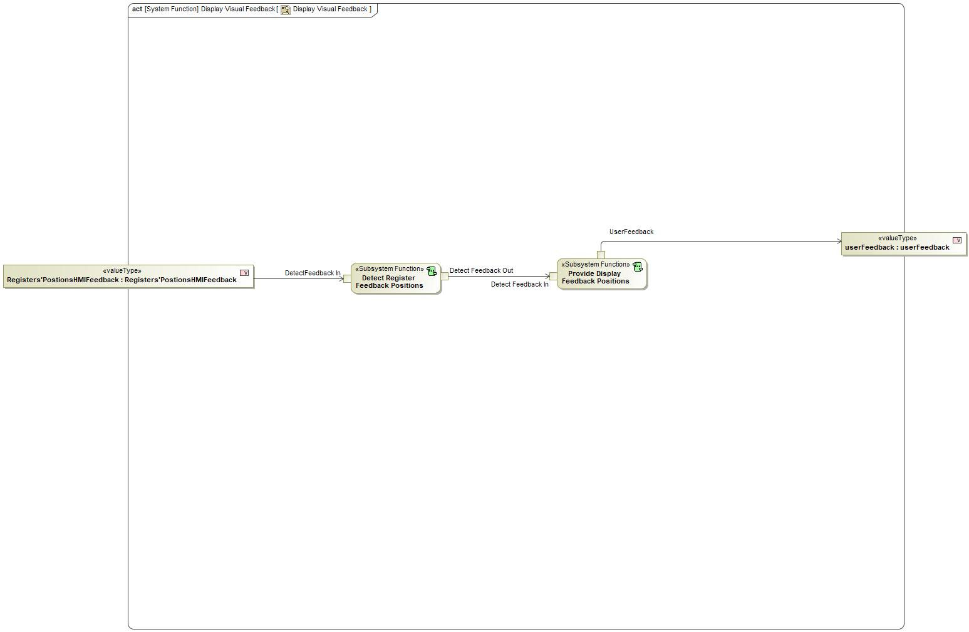

Figure 2: Activity Diagram of 569628064.jpg “Display Visual Feedback” calling 105625660.jpg “Detect Register Feedback Positions”

### Function Interfaces

**#Link:** [RE Wiki – Adding a Logical Signal or Parameter](http://wiki.ford.com/display/RequirementsEngineering/Adding+a+Logical+Signal+or+Parameter)

#### Logical Inputs

|  |  |
| --- | --- |
| **Signal Name** | **Description** |
| DetectFeedback In  Type:  1020239328.jpg Registers'PostionsHMIFeedback | Received from:   * 1261387158.jpg Activity Parameter Node: Registers'PostionsHMIFeedback |

#### Logical Outputs

|  |  |
| --- | --- |
| **Signal Name** | **Description** |
| Detect Feedback Out  Type:  802792400.jpg Registers'PositionsSensorFeedback | Sent to:   * 105625660.jpg Provide Display Feedback Positions |

#### Logical Parameters

**#Hint**: Put requirements for parameters here, which are implemented as configuration parameters using Method 2 or 3 or as parameters for calibration.

*Not supported by MagicDraw report generation.*

### Function Modeling

**#Classification:** Mandatory

**#Hint:** Typical modeling artifacts in this section are State Machines, Activity Diagrams / Flow Charts, Decision Tables, and possibly Sequence Diagrams, which can all be used as techniques to analyze the function requirements.

**#Links:** Analyze / Model Requirements: [RE Wiki – Analyze / Model Requirements](http://wiki.ford.com/pages/viewpage.action?pageId=110594919&src=contextnavpagetreemode)

#### Use Cases

**#Classification:** Infotainment Only (remove section, if not used)

**#Hint:** Some Domains (e.g. Infotainment) use not only Customer Use Cases (in the Feature Doc), but refine Use Case descriptions down to function level. In general, the RE approach encourages the use of Use Cases on Feature Level but not on Function Level. Activity Diagrams are a more suitable way to express the same on Function Level.

**#Links:** Infotainment – “Harmony Systems Engineering” Approach

*Not supported by MagicDraw report generation.*

#### State Charts / Activity Diagrams / Sequence Diagrams / Decision Tables

**#Classification:** Mandatory

**#Hint:** It is highly recommended to use at least one of the following modeling techniques for modeling and analyzing the Function behavior and derived requirements (refer to sample diagrams below):

State Machines, Activity Diagrams / Flow Charts, or Decision Tables

Optionally, Sequence Diagrams might help to analyze the interaction between Functions.

**#Links:** Analyze / Model Requirements: [RE Wiki – Analyze / Model Requirements](http://wiki.ford.com/pages/viewpage.action?pageId=110594919&src=contextnavpagetreemode)

State Charts [RE Wiki – State Charts](http://wiki.ford.com/display/RequirementsEngineering/State+Charts?src=contextnavpagetreemode)

Activity Diagrams: [RE Wiki – Activity Diagram](http://wiki.ford.com/display/RequirementsEngineering/Activity+Diagram?src=contextnavpagetreemode), [SysML User Group – Activity Diagram Basics](https://pd3.spt.ford.com/sites/SystemsEngineering/SEC/sysml-teamsite/SysML%20Wiki/Activity%20Diagram%20Basics.aspx)

Sequence Diagrams: [RE Wiki – Sequence Chart](http://wiki.ford.com/display/RequirementsEngineering/Sequence+Chart?src=contextnavpagetreemode), [SysML User Group – Sequence Diagram Basics](https://pd3.spt.ford.com/sites/SystemsEngineering/SEC/sysml-teamsite/SysML%20Wiki/Sequence%20Diagram%20Basics.aspx)

No diagrams internal to function specified.

### Function Requirements

#Link: [*RE Wiki – How to write good requirements*](http://wiki.ford.com/display/RequirementsEngineering/How+to+write+better+requirements?src=contextnavpagetreemode)

#### Functional Requirements

***#Hint:*** *Please also consider specific situations like Initialization (Startup) and Deinitialization (Shutdown) apart from Normal Operation and Error Handling. E.g. a* state chart or activity diagram might help for better understanding.

##### Normal Operation

Detect Register Feedback Positions

When system subfunction "Detect Register Feedback Positions" receives the signal "Detect Feedback" it shall forward the signal to the "Provide Display Feedback Positons"

|  |  |  |  |  |  |  |  |
| --- | --- | --- | --- | --- | --- | --- | --- |
| Requirement ID: | | | | | | | |
| **Rationale** |  | | | | | | |
| **Acceptance Criteria** |  | | | | | | |
| **Notes** |  | | | | | | |
| **Source** |  | | | | | **Owner** |  |
| **Source Req.** | * -1193871816.jpg HMI System Functionality * -1193871816.jpg Display Visual Feedback | | | | | **V&V Method** |  |
| **Type** |  | | | **Priority** |  | **Status** |  |
| [Req. Template](http://wiki.ford.com/display/RequirementsEngineering/Requirements+Attributes) Version | | 6.0 | End of Requirement | | | | |

##### Error Handling

***#Hint:*** *FMEA counter measures could be considered as requirements in this chapter*

No Error Handling Requirements specified.

#### Non-Functional Requirements

***#Hint:*** *Non-functional requirements specify some performance criteria in addition to the functional behavior given defined by the functional requirements. Timing (if not already included in the functional requirements), security details (e.g. how secure does an algorithm have to be) or reliability (e.g. mean time between failure) could be specified in this section.*

No Non-Functional Requirements specified.

#### Functional Safety Requirements

**#Classification**: Functional Safety only – If not used, remove content and state “Not Applicable”

***#Hint:*** *Add Functional Safety Requirements (FSRs) derived for this function.*

**#Link:** [Functional Safety Sharepoint](https://pd3.spt.ford.com/sites/GlobalFunctionalSafety/Pages/default.aspx) – Functional Safety Concept

[RE Wiki - Requirements Attributes](http://wiki.ford.com/display/RequirementsEngineering/Requirements+Attributes)

No Functional Safety Requirements specified.

##### ASIL Decomposition of Functional Safety Requirements

**#Classification**: Functional Safety only – If not used, remove content and state “Not Applicable”

***#Hint:*** *Sometimes an ASIL decomposition of Functional Safety Requirements is required. The decomposed FSRs should be listed beneath each ASIL Decomposition table below and referenced inside the table by ID and Title*

**#Link:** [Functional Safety Sharepoint](https://pd3.spt.ford.com/sites/GlobalFunctionalSafety/Pages/default.aspx) – Functional Safety Concept

No Functional Safety Requirements with ASIL Decompositions specified.

#### Other Requirements

##### Design Requirements

***#Hint:*** *Requirements of a Logical Function should be typically agnostic of their SW/HW implementation*. If for specific reasons the function owner needs to define explicitly design constraints, it can be done in this chapter.

No Design Requirements specified.

## 105625660.jpg Detect User Input

### Function Overview

#### Description

Function is allocated to:

* 143394815.jpg Analyze Input <<Logical>>
* 970518553.jpg EM Registers Vehicle Domain <<Logical>>
* 143394815.jpg Provide UserInput <<Logical>>
* -904097280.jpg Register Controller <<Logical>>
* 143394815.jpg Request Register Change <<Logical>>

senses user input from HMI

#### Variants

*Not supported by MagicDraw report generation.*

#### Input Requirements

*Not supported by MagicDraw report generation.*

#### Assumptions

No assumptions specified for this function.

#### References

##### Ford Documents

List here all Ford internal documents, which are directly related to the feature.

| **Reference** | **Title** | **Doc. ID** | **Revision** |
| --- | --- | --- | --- |
|  |  |  |  |

Table 5: Ford internal Documents *(not specified in model)*

##### External Documents and Publications

The list of external documents could include books, reports and online sources.

| **Reference** | **Document / Publication** |
| --- | --- |
|  |  |

Table 7: External documents and publications *(not specified in model)*

#### Glossary

See Appendix for Definitions and Abbreviations.

### Function Scope

The 105625660.jpg **– “Detect User Input”** function is called by the following functions:

* 569628064.jpg – “Provide Climate system with User Input”

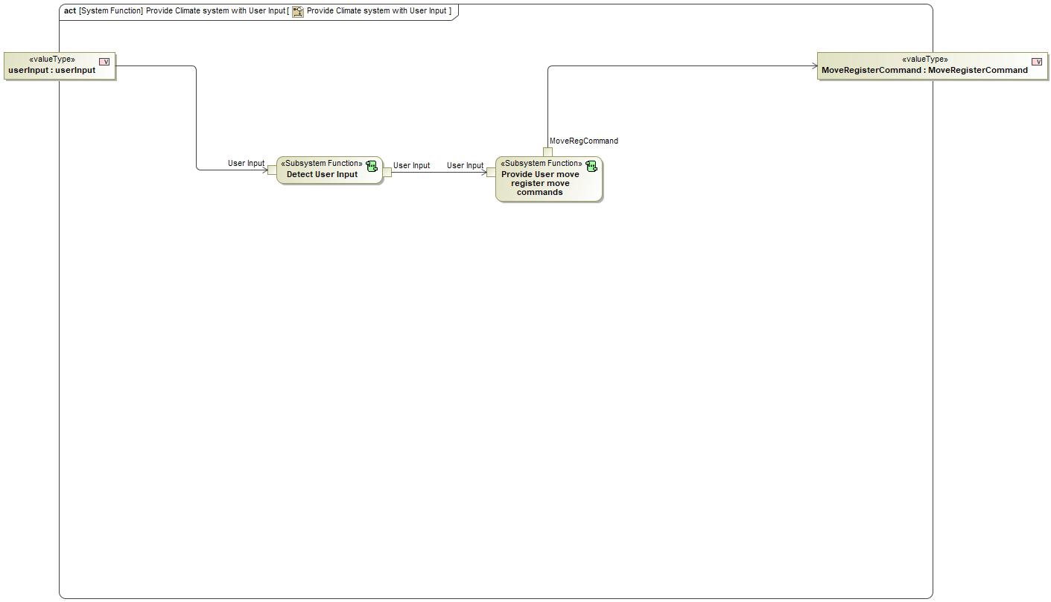

Figure 2: Activity Diagram of 569628064.jpg “Provide Climate system with User Input” calling 105625660.jpg “Detect User Input”

### Function Interfaces

#### Logical Inputs

|  |  |
| --- | --- |
| **Signal Name** | **Description** |
| User Input  Type:  1020239328.jpg userInput | Received from:   * 1261387158.jpg Activity Parameter Node: userInput |

#### Logical Outputs

|  |  |
| --- | --- |
| **Signal Name** | **Description** |
| User Input | Sent to:   * 105625660.jpg Provide User move register move commands |

#### Logical Parameters

*Not supported by MagicDraw report generation.*

### Function Modeling

#### Use Cases

*Not supported by MagicDraw report generation.*

#### State Charts / Activity Diagrams / Sequence Diagrams / Decision Tables

No diagrams internal to function specified.

### Function Requirements

#### Functional Requirements

##### Normal Operation

Detect User Input

When subsystem function receives the signal "userinput", it shall forward the signal to the subsystem function "Provide User Input"

|  |  |  |  |  |  |  |  |
| --- | --- | --- | --- | --- | --- | --- | --- |
| Requirement ID: | | | | | | | |
| **Rationale** |  | | | | | | |
| **Acceptance Criteria** |  | | | | | | |
| **Notes** |  | | | | | | |
| **Source** |  | | | | | **Owner** |  |
| **Source Req.** | * -1193871816.jpg HMI System Functionality * -1193871816.jpg Display Visual Feedback | | | | | **V&V Method** |  |
| **Type** |  | | | **Priority** |  | **Status** |  |
| [Req. Template](http://wiki.ford.com/display/RequirementsEngineering/Requirements+Attributes) Version | | 6.0 | End of Requirement | | | | |

##### Error Handling

No Error Handling Requirements specified.

#### Non-Functional Requirements

No Non-Functional Requirements specified.

#### Functional Safety Requirements

No Functional Safety Requirements specified.

##### ASIL Decomposition of Functional Safety Requirements

No Functional Safety Requirements with ASIL Decompositions specified.

#### Other Requirements

##### Design Requirements

No Design Requirements specified.

## 569628064.jpg Display Visual Feedback

### Function Overview

#### Description

Function is allocated to:

* 970518553.jpg EM Registers Vehicle Domain <<Logical>>
* 970518553.jpg HMI System <<Logical>>

Shows the user the HMI that visually depicts the register positions and various selections.

#### Variants

*Not supported by MagicDraw report generation.*

#### Input Requirements

*Not supported by MagicDraw report generation.*

#### Assumptions

No assumptions specified for this function.

#### References

##### Ford Documents

List here all Ford internal documents, which are directly related to the feature.

| **Reference** | **Title** | **Doc. ID** | **Revision** |
| --- | --- | --- | --- |
|  |  |  |  |

Table 5: Ford internal Documents *(not specified in model)*

##### External Documents and Publications

The list of external documents could include books, reports and online sources.

| **Reference** | **Document / Publication** |
| --- | --- |
|  |  |

Table 7: External documents and publications *(not specified in model)*

#### Glossary

See Appendix for Definitions and Abbreviations.

### Function Scope

The 569628064.jpg **– “Display Visual Feedback”** function is called by the following functions:

* -1497236451.jpg – “Display Visual Feedback”
* 708421765.jpg – “Move Registers”

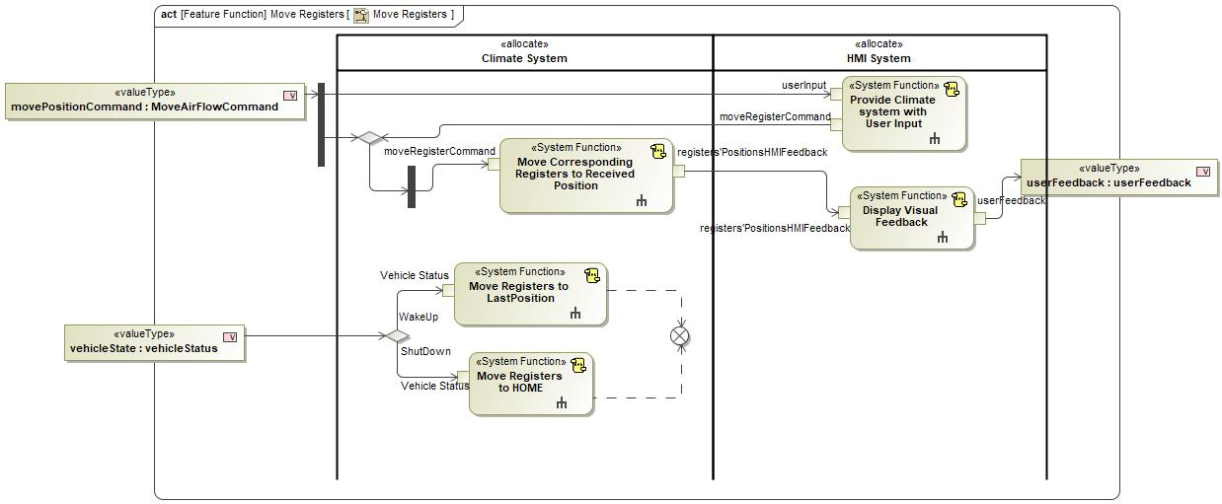

Figure 2: Activity Diagram of 708421765.jpg “Move Registers” calling 569628064.jpg “Display Visual Feedback”

### Function Interfaces

#### Logical Inputs

|  |  |
| --- | --- |
| **Signal Name** | **Description** |
| Registers'PostionsHMIFeedback  Type:  1020239328.jpg Registers'PostionsHMIFeedback | Received from:   * 569628064.jpg Move Corresponding Registers to Received Position |

#### Logical Outputs

|  |  |
| --- | --- |
| **Signal Name** | **Description** |
| userFeedback  Type:  -567301788.jpg userFeedback | Sent to:   * 1261387158.jpg Activity Parameter Node: userFeedback |

#### Logical Parameters

*Not supported by MagicDraw report generation.*

### Function Modeling

#### Use Cases

*Not supported by MagicDraw report generation.*

#### State Charts / Activity Diagrams / Sequence Diagrams / Decision Tables



Figure 3: Display Visual Feedback

### Function Requirements

#### Functional Requirements

##### Normal Operation

HMI System Functionality

HMI System shall provide MoveRegisterCommand and receive "Registers'PostionsHMIFeedback".

|  |  |  |  |  |  |  |  |
| --- | --- | --- | --- | --- | --- | --- | --- |
| Requirement ID: | | | | | | | |
| **Rationale** |  | | | | | | |
| **Acceptance Criteria** |  | | | | | | |
| **Notes** |  | | | | | | |
| **Source** |  | | | | | **Owner** |  |
| **Source Req.** | * -124368076.jpg EM Reg HMI Functionality * 373076138.jpg HMI Feedback * -1618143751.jpg EM Reg Move Command * -1618143751.jpg EM Reg Preset Aim Memo * -547336611.jpg HVAC Vent Air Flow Direction Interface * -124368076.jpg EM Reg HMI Feedback * -1618143751.jpg EM Reg Preset Command | | | | | **V&V Method** |  |
| **Type** |  | | | **Priority** |  | **Status** |  |
| [Req. Template](http://wiki.ford.com/display/RequirementsEngineering/Requirements+Attributes) Version | | 6.0 | End of Requirement | | | | |

Display Visual Feedback

"Display Visual Feedback" system function shall display the status of EM registers to the user through HMI, when it receives the register status through "Registers'PostionsHMIFeedback" input.

|  |  |  |  |  |  |  |  |
| --- | --- | --- | --- | --- | --- | --- | --- |
| Requirement ID: | | | | | | | |
| **Rationale** |  | | | | | | |
| **Acceptance Criteria** |  | | | | | | |
| **Notes** |  | | | | | | |
| **Source** |  | | | | | **Owner** |  |
| **Source Req.** | * 373076138.jpg HMI Feedback * -124368076.jpg EM Reg HMI Feedback | | | | | **V&V Method** |  |
| **Type** |  | | | **Priority** |  | **Status** |  |
| [Req. Template](http://wiki.ford.com/display/RequirementsEngineering/Requirements+Attributes) Version | | 6.0 | End of Requirement | | | | |

##### Error Handling

No Error Handling Requirements specified.

#### Non-Functional Requirements

No Non-Functional Requirements specified.

#### Functional Safety Requirements

No Functional Safety Requirements specified.

##### ASIL Decomposition of Functional Safety Requirements

No Functional Safety Requirements with ASIL Decompositions specified.

#### Other Requirements

##### Design Requirements

No Design Requirements specified.

## 569628064.jpg Provide Climate system with User Input

### Function Overview

#### Description

Function is allocated to:

* 970518553.jpg Climate System <<Logical>>
* 970518553.jpg EM Registers Vehicle Domain <<Logical>>
* 970518553.jpg HMI System <<Logical>>

Senses user input and gives said input/selection to the Climate system.

#### Variants

*Not supported by MagicDraw report generation.*

#### Input Requirements

*Not supported by MagicDraw report generation.*

#### Assumptions

No assumptions specified for this function.

#### References

##### Ford Documents

List here all Ford internal documents, which are directly related to the feature.

| **Reference** | **Title** | **Doc. ID** | **Revision** |
| --- | --- | --- | --- |
|  |  |  |  |

Table 5: Ford internal Documents *(not specified in model)*

##### External Documents and Publications

The list of external documents could include books, reports and online sources.

| **Reference** | **Document / Publication** |
| --- | --- |
|  |  |

Table 7: External documents and publications *(not specified in model)*

#### Glossary

See Appendix for Definitions and Abbreviations.

### Function Scope

The 569628064.jpg **– “Provide Climate system with User Input”** function is called by the following functions:

* 708421765.jpg – “Move Registers”
* 708421765.jpg – “Save LastPosition in Preset”
* 708421765.jpg – “Store Registers' Positions”



Figure 2: Activity Diagram of 708421765.jpg “Move Registers” calling 569628064.jpg “Provide Climate system with User Input”

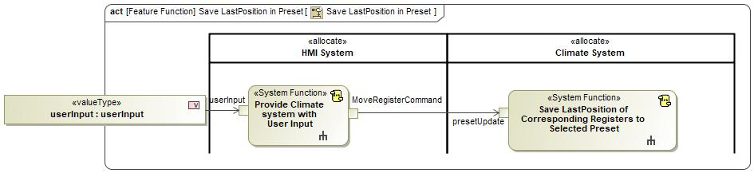

Figure 2: Activity Diagram of 708421765.jpg “Save LastPosition in Preset” calling 569628064.jpg “Provide Climate system with User Input”

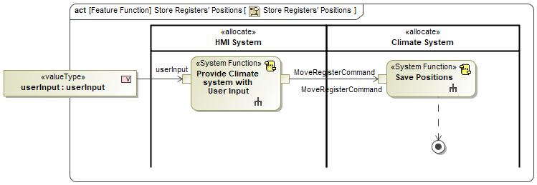

Figure 2: Activity Diagram of 708421765.jpg “Store Registers' Positions” calling 569628064.jpg “Provide Climate system with User Input”

### Function Interfaces

#### Logical Inputs

|  |  |
| --- | --- |
| **Signal Name** | **Description** |
| userInput  Type:  1020239328.jpg userInput | Received from:   * 1261387158.jpg Activity Parameter Node: userInput * 1261387158.jpg Activity Parameter Node: movePositionCommand * 1261387158.jpg Activity Parameter Node: userInput |

#### Logical Outputs

|  |  |
| --- | --- |
| **Signal Name** | **Description** |
| MoveRegisterCommand  Type:  1020239328.jpg MoveRegisterCommand | Sent to:   * 569628064.jpg Save Positions * 569628064.jpg Save LastPosition of Corresponding Registers to Selected Preset * 569628064.jpg Move Corresponding Registers to Received Position |

#### Logical Parameters

*Not supported by MagicDraw report generation.*

### Function Modeling

#### Use Cases

*Not supported by MagicDraw report generation.*

#### State Charts / Activity Diagrams / Sequence Diagrams / Decision Tables



Figure 3: Provide Climate system with User Input

### Function Requirements

#### Functional Requirements

##### Normal Operation

HMI System Functionality

HMI System shall provide MoveRegisterCommand and receive "Registers'PostionsHMIFeedback".

|  |  |  |  |  |  |  |  |
| --- | --- | --- | --- | --- | --- | --- | --- |
| Requirement ID: | | | | | | | |
| **Rationale** |  | | | | | | |
| **Acceptance Criteria** |  | | | | | | |
| **Notes** |  | | | | | | |
| **Source** |  | | | | | **Owner** |  |
| **Source Req.** | * -124368076.jpg EM Reg HMI Functionality * 373076138.jpg HMI Feedback * -1618143751.jpg EM Reg Move Command * -1618143751.jpg EM Reg Preset Aim Memo * -547336611.jpg HVAC Vent Air Flow Direction Interface * -124368076.jpg EM Reg HMI Feedback * -1618143751.jpg EM Reg Preset Command | | | | | **V&V Method** |  |
| **Type** |  | | | **Priority** |  | **Status** |  |
| [Req. Template](http://wiki.ford.com/display/RequirementsEngineering/Requirements+Attributes) Version | | 6.0 | End of Requirement | | | | |

HMI to Climate System User Input

"Provide Climate System With User Input" system function shall provide the climate system with "MoveRegisterCommand" when it receives userInput.

|  |  |  |  |  |  |  |  |
| --- | --- | --- | --- | --- | --- | --- | --- |
| Requirement ID: | | | | | | | |
| **Rationale** |  | | | | | | |
| **Acceptance Criteria** |  | | | | | | |
| **Notes** |  | | | | | | |
| **Source** |  | | | | | **Owner** |  |
| **Source Req.** | * -124368076.jpg EM Reg HMI Functionality * -547336611.jpg Personalizable * -1618143751.jpg EM Reg Preset Aim Memo * -547336611.jpg HVAC Vent Air Flow Direction Interface | | | | | **V&V Method** |  |
| **Type** |  | | | **Priority** |  | **Status** |  |
| [Req. Template](http://wiki.ford.com/display/RequirementsEngineering/Requirements+Attributes) Version | | 6.0 | End of Requirement | | | | |

##### Error Handling

No Error Handling Requirements specified.

#### Non-Functional Requirements

No Non-Functional Requirements specified.

#### Functional Safety Requirements

No Functional Safety Requirements specified.

##### ASIL Decomposition of Functional Safety Requirements

No Functional Safety Requirements with ASIL Decompositions specified.

#### Other Requirements

##### Design Requirements

No Design Requirements specified.

## 105625660.jpg Provide Display Feedback Positions

### Function Overview

#### Description

Function is allocated to:

* 970518553.jpg EM Registers Vehicle Domain <<Logical>>
* -463306694.jpg Provide User Feedback <<Logical>>
* -904097280.jpg Register Controller <<Logical>>

detects register positions feedback from register move command

#### Variants

*Not supported by MagicDraw report generation.*

#### Input Requirements

*Not supported by MagicDraw report generation.*

#### Assumptions

No assumptions specified for this function.

#### References

##### Ford Documents

List here all Ford internal documents, which are directly related to the feature.

| **Reference** | **Title** | **Doc. ID** | **Revision** |
| --- | --- | --- | --- |
|  |  |  |  |

Table 5: Ford internal Documents *(not specified in model)*

##### External Documents and Publications

The list of external documents could include books, reports and online sources.

| **Reference** | **Document / Publication** |
| --- | --- |
|  |  |

Table 7: External documents and publications *(not specified in model)*

#### Glossary

See Appendix for Definitions and Abbreviations.

### Function Scope

The 105625660.jpg **– “Provide Display Feedback Positions”** function is called by the following functions:

* 569628064.jpg – “Display Visual Feedback”



Figure 2: Activity Diagram of 569628064.jpg “Display Visual Feedback” calling 105625660.jpg “Provide Display Feedback Positions”

### Function Interfaces

#### Logical Inputs

|  |  |
| --- | --- |
| **Signal Name** | **Description** |
| Detect Feedback In  Type:  802792400.jpg Registers'PositionsSensorFeedback | Received from:   * 105625660.jpg Detect Register Feedback Positions |

#### Logical Outputs

|  |  |
| --- | --- |
| **Signal Name** | **Description** |
| UserFeedback  Type:  -567301788.jpg userFeedback | Sent to:   * 1261387158.jpg Activity Parameter Node: userFeedback |

#### Logical Parameters

*Not supported by MagicDraw report generation.*

### Function Modeling

#### Use Cases

*Not supported by MagicDraw report generation.*

#### State Charts / Activity Diagrams / Sequence Diagrams / Decision Tables

No diagrams internal to function specified.

### Function Requirements

#### Functional Requirements

##### Normal Operation

Provide Display Feedback Positions

When subsystem function receives the signal 'Register Positions Feedback', it shall forward the signal "UserFeedback' to the HMI display

|  |  |  |  |  |  |  |  |
| --- | --- | --- | --- | --- | --- | --- | --- |
| Requirement ID: | | | | | | | |
| **Rationale** |  | | | | | | |
| **Acceptance Criteria** |  | | | | | | |
| **Notes** |  | | | | | | |
| **Source** |  | | | | | **Owner** |  |
| **Source Req.** | * -1193871816.jpg HMI System Functionality * -1193871816.jpg Display Visual Feedback | | | | | **V&V Method** |  |
| **Type** |  | | | **Priority** |  | **Status** |  |
| [Req. Template](http://wiki.ford.com/display/RequirementsEngineering/Requirements+Attributes) Version | | 6.0 | End of Requirement | | | | |

##### Error Handling

No Error Handling Requirements specified.

#### Non-Functional Requirements

No Non-Functional Requirements specified.

#### Functional Safety Requirements

No Functional Safety Requirements specified.

##### ASIL Decomposition of Functional Safety Requirements

No Functional Safety Requirements with ASIL Decompositions specified.

#### Other Requirements

##### Design Requirements

No Design Requirements specified.

## 105625660.jpg Provide User move register move commands

### Function Overview

#### Description

Function is allocated to:

* 970518553.jpg EM Registers Vehicle Domain <<Logical>>
* -463306694.jpg Provide ON/OFF Move Request <<Logical>>
* -904097280.jpg Register Controller <<Logical>>

provides move register move commands

#### Variants

*Not supported by MagicDraw report generation.*

#### Input Requirements

*Not supported by MagicDraw report generation.*

#### Assumptions

No assumptions specified for this function.

#### References

##### Ford Documents

List here all Ford internal documents, which are directly related to the feature.

| **Reference** | **Title** | **Doc. ID** | **Revision** |
| --- | --- | --- | --- |
|  |  |  |  |

Table 5: Ford internal Documents *(not specified in model)*

##### External Documents and Publications

The list of external documents could include books, reports and online sources.

| **Reference** | **Document / Publication** |
| --- | --- |
|  |  |

Table 7: External documents and publications *(not specified in model)*

#### Glossary

See Appendix for Definitions and Abbreviations.

### Function Scope

The 105625660.jpg **– “Provide User move register move commands ”** function is called by the following functions:

* 569628064.jpg – “Provide Climate system with User Input”



Figure 2: Activity Diagram of 569628064.jpg “Provide Climate system with User Input” calling 105625660.jpg “Provide User move register move commands ”

### Function Interfaces

#### Logical Inputs

|  |  |
| --- | --- |
| **Signal Name** | **Description** |
| User Input | Received from:   * 105625660.jpg Detect User Input |

#### Logical Outputs

|  |  |
| --- | --- |
| **Signal Name** | **Description** |
| MoveRegCommand  Type:  1020239328.jpg MoveRegisterCommand | Sent to:   * 1261387158.jpg Activity Parameter Node: MoveRegisterCommand |

#### Logical Parameters

*Not supported by MagicDraw report generation.*

### Function Modeling

#### Use Cases

*Not supported by MagicDraw report generation.*

#### State Charts / Activity Diagrams / Sequence Diagrams / Decision Tables

No diagrams internal to function specified.

### Function Requirements

#### Functional Requirements

##### Normal Operation

Provide User Input

When subsytem function receives the signal 'userinput', it shall provide the signal 'MoveRegisterCommand'

|  |  |  |  |  |  |  |  |
| --- | --- | --- | --- | --- | --- | --- | --- |
| Requirement ID: | | | | | | | |
| **Rationale** |  | | | | | | |
| **Acceptance Criteria** |  | | | | | | |
| **Notes** |  | | | | | | |
| **Source** |  | | | | | **Owner** |  |
| **Source Req.** | * -1193871816.jpg HMI System Functionality * -1193871816.jpg Display Visual Feedback | | | | | **V&V Method** |  |
| **Type** |  | | | **Priority** |  | **Status** |  |
| [Req. Template](http://wiki.ford.com/display/RequirementsEngineering/Requirements+Attributes) Version | | 6.0 | End of Requirement | | | | |

##### Error Handling

No Error Handling Requirements specified.

#### Non-Functional Requirements

No Non-Functional Requirements specified.

#### Functional Safety Requirements

No Functional Safety Requirements specified.

##### ASIL Decomposition of Functional Safety Requirements

No Functional Safety Requirements with ASIL Decompositions specified.

#### Other Requirements

##### Design Requirements

No Design Requirements specified.

# Open Concerns

**#Hint:** The following list presents open concerns, which have to be discussed or clarified over the course of the on-going requirements engineering.

| ID | Concern Description | e-Tracker / Reference | Responsible | Status | Solution |
| --- | --- | --- | --- | --- | --- |
| 1 |  |  |  |  |  |

Table 8: Open Concerns *(Not supported by MagicDraw report generation.)*

# Revision History

**#Hint:** A new version number is assigned to a document with a given revision each time it is checked in to Team Center (TCSE). After release of a revision, the document cannot be edited and no new versions can be created on that revision. When updating the document after that, a new revision has to be created and new versions on that revision will be created upon checking in.

No Revision History found.

## Template Revisions

*#Important: Do not change this section*

|  |  |  |  |  |
| --- | --- | --- | --- | --- |
| Version | Rev. | Date | Description | Responsible |
| *1* | *0* | *2016-02-26* | *Initial version, derived from FDS* | *Jbaden1* |
| *1* | *1* | *2016-02-26* | *Word properties corrected* | *Jbaden1* |
| *1* | *2* | *2016-03-10* | *Clean up of document meta data (Word properties)* | *Jbaden1* |
| *1* | *3* | *2016-03-22* | * *Footer formatting corrected (Issue 19)* * *“Constraints” chapter renamed to “Input Requirements” (Issue 20)* | *Jbaden1* |
| *1* | *4* | *2016-04-20* | * *Broken Wiki links repaired* | *Jbaden1* |
| *2* | *0* | *2016-06-10* | * *Document metadata adapted. Prepared for new macros* * *DTC table removed* * *HMI function added as a chapter (details still to be refined)* * *Signal / Parameter IDs column deleted interface tables* | *Jbaden1* |
| *2* | *1* | *2016-07-14* | * *Converted to SysML diagrams* * *HMI section further elaborated* * *Template version added to footer* * *Dedicated Startup / Shutdown sections removed (only hints added)* * *Data Dictionary reworked and Signal / Parameter IDs column re-introduced* | *Jbaden1* |
| *2* | *2* | *2016-12-07* | * *Minor formatting changes* | *Jbaden1* |
| *3* |  |  | *Skipped to synchronize with Specification_Macros.dotm* |  |
| *4* |  |
| *5* | *0* | *2017-01-13* | * *Meta data updated for specification macros, version 3.1* * *SW Unit chapter removed for the time being* * *Green boxes added for user hints* | *Jbaden1* |
| *5* | *1* | *2017-01-18* | * *Some additional hints.* * *Hyperlinks highlighted in hints* | *Jbaden1* |
| *6* | *0* | *2017-04-28* | * *Editorial change. Hints added to chapter 4.1.4* * *Chapter “Traceability Matrix” removed* | *Jbaden1* |
| *6* | *0* | *2018-04-28* | * *CR69/63: New chapters added for Functional Safety (FTTI and Technical Safety Requirements)* * *CR53: New coversheet + additional meta-data* * *CR76: merge sections for configuration and for calibration parameters into one on Function Level* | *Jbaden1* |
| *6* | *0* | *2018-08-06* | * *CR66: Fix version numbering in footer of Function Spec* | *Jbaden1* |
| *6* | *0* | *2018-09-28* | * *Broken links to RE Wiki repaired* | *Jbaden1* |
| *6* | *0* | *2018-10-31* | * *Minor corrections on cover sheet and in footer to be more GIS compliant and VSEM aligned* * *“Overview” and “Description” exchanged in headings (following common sense)* | *Jbaden1* |
| *6* | *0* | *2018-11-12* | * *Explanatory text in Variants” section revised* * *Functional Safety modifications as agreed with FuSa core team (Baseline: November 2018 Dearborn On-Site)* | *Jbaden1* |
| *M* |  | *2019-04-02* | * *Initial version of SysML report template* | *snuesch* |
| *M* |  | *2019-04-05* | * *Improved dialog boxes to select function group* | *snuesch* |
| *M* |  | *2019-04-26* | * *Improved function interfaces (support of additional elements (e.g., send signal action, add structural feature action, merge node, decision node, activity parameter nodes, etc.) and pins)* | *snuesch* |
| *N* |  | *2019-08-19* | * *For each function now also requirements satisfied by activity parameter nodes and function outputs are populated.* | *snuesch* |
| *N* |  | *2019-08-21* | * *Improved glossary and acronym tables* | *snuesch* |
| *N* |  | *2019-09-20* | * *Updated Function Interfaces tables with better wording. Added a report template variable that allows to disable senders and receivers. Sorted requirements by ID.* | *snuesch* |
| *N* |  | *2019-09-27* | * *Green hints now only show up for first function.* * *labelTag variable can be used to filter revision history.* | *snuesch* |

# Appendix

## Data Dictionary

### Logical Signals

**#Macro:** [Add Ins -> Add Requirement macro](http://wiki.ford.com/display/RequirementsEngineering/Adding+a+Logical+Signal+or+Parameter) (select “Logical Signal” as type)

MoveRegisterCommand

|  |  |  |
| --- | --- | --- |
| **ASIL** | |  |
| **Encoding Type Name** | |  |
| Note: An encoding is either discrete or continuous. Delete fields below which are not needed | | |
| **Value**  (Continuous Encoding) | Min Value |  |
| Max Value |  |
| Resolution |  |
| Offset |  |
| **Value**  (Discrete  Encoding) |  |  |
| **Unit** | |  |

Registers'PositionsSensorFeedback

|  |  |  |
| --- | --- | --- |
| **ASIL** | |  |
| **Encoding Type Name** | |  |
| Note: An encoding is either discrete or continuous. Delete fields below which are not needed | | |
| **Value**  (Continuous Encoding) | Min Value |  |
| Max Value |  |
| Resolution |  |
| Offset |  |
| **Value**  (Discrete  Encoding) |  |  |
| **Unit** | |  |

Registers'PostionsHMIFeedback

|  |  |  |
| --- | --- | --- |
| **ASIL** | |  |
| **Encoding Type Name** | |  |
| Note: An encoding is either discrete or continuous. Delete fields below which are not needed | | |
| **Value**  (Continuous Encoding) | Min Value |  |
| Max Value |  |
| Resolution |  |
| Offset |  |
| **Value**  (Discrete  Encoding) |  |  |
| **Unit** | |  |

userFeedback

|  |  |  |
| --- | --- | --- |
| **ASIL** | |  |
| **Encoding Type Name** | |  |
| Note: An encoding is either discrete or continuous. Delete fields below which are not needed | | |
| **Value**  (Continuous Encoding) | Min Value |  |
| Max Value |  |
| Resolution |  |
| Offset |  |
| **Value**  (Discrete  Encoding) |  |  |
| **Unit** | |  |

userInput

|  |  |  |
| --- | --- | --- |
| **ASIL** | |  |
| **Encoding Type Name** | |  |
| Note: An encoding is either discrete or continuous. Delete fields below which are not needed | | |
| **Value**  (Continuous Encoding) | Min Value |  |
| Max Value |  |
| Resolution |  |
| Offset |  |
| **Value**  (Discrete  Encoding) |  |  |
| **Unit** | |  |

### Logical Parameters

**#Macro:** [Add Ins -> Add Requirement macro](http://wiki.ford.com/display/RequirementsEngineering/Adding+a+Logical+Signal+or+Parameter) (select “Logical Parameter” as type)

### Encoding Types

**#Macro:** [Add Ins -> Add Requirement macro](http://wiki.ford.com/display/RequirementsEngineering/Adding+an+Encoding+Type) (select “Encoding Type” as type)

## Glossary

**#Hint**: Terms, concepts and abbreviations used in the document shall be defined and illustrated here. Note that changes to terms and/or concepts described in this section tend to cause major updates to this document.

The tables below have feature specific definitions and abbreviations. For additional, non-feature specific terms please refer to the [RE Glossary](http://wiki.ford.com/display/RequirementsEngineering/Glossary?src=contextnavpagetreemode)

### Definitions

**#Hint:** The table below has definitions and abbreviations relevant for the functions in this document. For additional terms please refer to the [RE Glossary](http://wiki.ford.com/display/RequirementsEngineering/Glossary?src=contextnavpagetreemode)

| **Definition** | **Description** |
| --- | --- |
| status of EM registers |  |

Table 9: Definitions used in this document

### Abbreviations

No acronyms specified.

Document ends here.